Name : Tushar Pathak
RegNumber : 230905396
Roll Number: B48

Lab 10: Programs using diff. CUDA device memory types and synchronization

//Sample at the end of the file

Q1)Write a program in CUDA to perform matrix multiplication using 2D Grid and 2D Block.

Code:
#include <stdio.h>
#include <stdlib.h>
#include <math.h>
#include <cuda_runtime.h>

// A is (rowsA x colsA), B is (colsA x colsB), C is (rowsA x colsB)
__global__ void matMulKernel(float *A, float *B, float *C, int rowsA, int colsA, int colsB) {
int row = blockIdx.y * blockDim.y + threadIdx.y;
int col = blockIdx.x * blockDim.x + threadIdx.x;

if (row < rowsA && col < colsB) {
float sum = 0.0f;
for (int k = 0; k < colsA; k++)
sum += A[row * colsA + k] * B[k * colsB + col];
C[row * colsB + col] = sum;
}
}

int main() {
int rowsA, colsA, colsB;

printf("Enter rows of A: ");
scanf("%d", &rowsA);
printf("Enter cols of A (= rows of B): ");
scanf("%d", &colsA);
printf("Enter cols of B: ");
scanf("%d", &colsB);

int rowsB = colsA; // must match

float *h_A = (float*)malloc(rowsA * colsA * sizeof(float));
float *h_B = (float*)malloc(rowsB * colsB * sizeof(float));
float *h_C = (float*)malloc(rowsA * colsB * sizeof(float));

// Input elements of A
printf("\nEnter elements of A (%d x %d):\n", rowsA, colsA);
for (int i = 0; i < rowsA; i++)
for (int j = 0; j < colsA; j++) {
scanf("%f", &h_A[i * colsA + j]);
}

printf("\nEnter elements of B (%d x %d):\n", rowsB, colsB);
for (int i = 0; i < rowsB; i++)
for (int j = 0; j < colsB; j++) {
scanf("%f", &h_B[i * colsB + j]);
}

float *d_A, *d_B, *d_C;
cudaMalloc(&d_A, rowsA * colsA * sizeof(float));
cudaMalloc(&d_B, rowsB * colsB * sizeof(float));
cudaMalloc(&d_C, rowsA * colsB * sizeof(float));

cudaMemcpy(d_A, h_A, rowsA * colsA * sizeof(float), cudaMemcpyHostToDevice);
cudaMemcpy(d_B, h_B, rowsB * colsB * sizeof(float), cudaMemcpyHostToDevice);

int TILE = 16;
dim3 blockDim(TILE, TILE);
dim3 gridDim((int)ceil((float)colsB / TILE), (int)ceil((float)rowsA / TILE));

printf("\nGrid: (%d, %d)\n", gridDim.x, gridDim.y);
printf("Block: (%d, %d)\n", blockDim.x, blockDim.y);

// Launch kernel
matMulKernel<<<gridDim, blockDim>>>(d_A, d_B, d_C, rowsA, colsA, colsB);
cudaDeviceSynchronize();

cudaMemcpy(h_C, d_C, rowsA * colsB * sizeof(float), cudaMemcpyDeviceToHost);

printf("\nResult Matrix C (%d x %d):\n", rowsA, colsB);
for (int i = 0; i < rowsA; i++) {
for (int j = 0; j < colsB; j++)
printf("%8.2f ", h_C[i * colsB + j]);
printf("\n");
}

cudaFree(d_A); cudaFree(d_B); cudaFree(d_C);
free(h_A); free(h_B); free(h_C);

return 0;
}

Output :

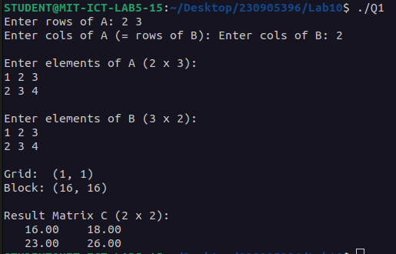

Q2)Write a program in CUDA to improve the performance of 1D parallel convolution using constant Memory.

Code:

#include <stdio.h>
#include <stdlib.h>
#include <cuda_runtime.h>

#define MAX_MASK_SIZE 10

__constant__ float d_M[MAX_MASK_SIZE];

__global__ void convolution1D(float *N, float *P, int mask_width, int width) {
int i = blockIdx.x * blockDim.x + threadIdx.x;
int half = mask_width / 2;

if (i < width) {
float sum = 0.0f;
for (int j = 0; j < mask_width; j++) {
int idx = i - half + j;
if (idx >= 0 && idx < width)
sum += N[idx] * d_M[j];
}
P[i] = sum;
}
}

int main() {
int width, mask_width;
printf("Enter array width: ");
scanf("%d", &width);
printf("Enter mask width (odd, max %d): ", MAX_MASK_SIZE);
scanf("%d", &mask_width);

float *h_N = (float*)malloc(width * sizeof(float));
float *h_M = (float*)malloc(mask_width * sizeof(float));
float *h_P = (float*)malloc(width * sizeof(float));

printf("Enter %d input values: ", width);
for (int i = 0; i < width; i++) scanf("%f", &h_N[i]);

printf("Enter %d mask values: ", mask_width);
for (int i = 0; i < mask_width; i++) scanf("%f", &h_M[i]);

float *d_N, *d_P;
cudaMalloc(&d_N, width * sizeof(float));
cudaMalloc(&d_P, width * sizeof(float));

cudaMemcpy(d_N, h_N, width * sizeof(float), cudaMemcpyHostToDevice);
cudaMemcpyToSymbol(d_M, h_M, mask_width * sizeof(float));

int BLOCK = 256;
dim3 blockDim(BLOCK);
dim3 gridDim((width + BLOCK - 1) / BLOCK);

convolution1D<<<gridDim, blockDim>>>(d_N, d_P, mask_width, width);
cudaDeviceSynchronize();

cudaMemcpy(h_P, d_P, width * sizeof(float), cudaMemcpyDeviceToHost);

printf("Output P: ");
for (int i = 0; i < width; i++) printf("%.2f ", h_P[i]);
printf("\n");

cudaFree(d_N); cudaFree(d_P);
free(h_N); free(h_M); free(h_P);
return 0;
}

Output:

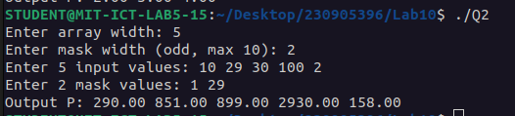

Q3) Write a program in CUDA to perform tiled 1D convolution operation on the input array N of size width using the mask array, M of size mask_width, to produce the resultant array P of size width
Code:
#include <stdio.h>
#include <stdlib.h>
#include <cuda_runtime.h>

#define MAX_MASK_SIZE 10
__constant__ float d_M[MAX_MASK_SIZE];

__global__ void tiledConvolution1D(float *N, float *P, int mask_width, int width) {
extern __shared__ float tile[];

int tx = threadIdx.x;
int out_idx = blockIdx.x * blockDim.x + tx;
int half = mask_width / 2;
int tile_size = blockDim.x + mask_width - 1;

int left = out_idx - half;
if (left >= 0 && left < width)
tile[tx] = N[left];
else
tile[tx] = 0.0f;

if (tx < mask_width - 1) {
int right = left + blockDim.x;
tile[blockDim.x + tx] = (right >= 0 && right < width) ? N[right] : 0.0f;
}

__syncthreads();

if (out_idx < width) {
float sum = 0.0f;
for (int j = 0; j < mask_width; j++)
sum += tile[tx + j] * d_M[j];
P[out_idx] = sum;
}
}

int main() {
int width, mask_width;
printf("Enter array width: ");
scanf("%d", &width);
printf("Enter mask width (odd, max %d): ", MAX_MASK_SIZE);
scanf("%d", &mask_width);

float *h_N = (float*)malloc(width * sizeof(float));
float *h_M = (float*)malloc(mask_width * sizeof(float));
float *h_P = (float*)malloc(width * sizeof(float));

printf("Enter %d input values: ", width);
for (int i = 0; i < width; i++) scanf("%f", &h_N[i]);

printf("Enter %d mask values: ", mask_width);
for (int i = 0; i < mask_width; i++) scanf("%f", &h_M[i]);

float *d_N, *d_P;
cudaMalloc(&d_N, width * sizeof(float));
cudaMalloc(&d_P, width * sizeof(float));

cudaMemcpy(d_N, h_N, width * sizeof(float), cudaMemcpyHostToDevice);
cudaMemcpyToSymbol(d_M, h_M, mask_width * sizeof(float));

int BLOCK = 256;
dim3 blockDim(BLOCK);
dim3 gridDim((width + BLOCK - 1) / BLOCK);

int shared_mem = (BLOCK + mask_width - 1) * sizeof(float);
tiledConvolution1D<<<gridDim, blockDim, shared_mem>>>(d_N, d_P, mask_width, width);
cudaDeviceSynchronize();

cudaMemcpy(h_P, d_P, width * sizeof(float), cudaMemcpyDeviceToHost);

printf("Output P: ");
for (int i = 0; i < width; i++) printf("%.2f ", h_P[i]);
printf("\n");

cudaFree(d_N); cudaFree(d_P);
free(h_N); free(h_M); free(h_P);
return 0;
}
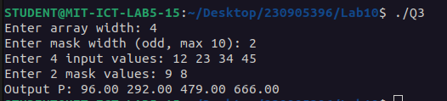
Output:
Sample Program
Code:
//Matrix multiplication of 4x4 matrix
#include <stdio.h>
#include <stdlib.h>
#include <unistd.h>
#include <cuda.h>
#define BLOCK_WIDTH 2
#define TILE_WIDTH 2
#define WIDTH 4

__global__ void MatMulElementThreadShared(int *a, int *b, int *c) {
__shared__ int MDs[TILE_WIDTH][TILE_WIDTH];
__shared__ int NDs[TILE_WIDTH][TILE_WIDTH];
int m;
int bx=blockIdx.x; int by=blockIdx.y;
int tx=threadIdx.x; int ty=threadIdx.y;
int Row=by*TILE_WIDTH + ty;
int Col= bx*TILE_WIDTH +tx;
int Pvalue=0;
for(m=0; m<WIDTH/TILE_WIDTH; m++)
{
MDs[ty][tx]=a[Row*WIDTH+m*TILE_WIDTH+tx];
NDs[ty][tx]=b[(m*TILE_WIDTH+ty)*WIDTH+Col];
__syncthreads();
for (int k = 0; k < TILE_WIDTH; k++)
{
Pvalue += MDs[ty][k]*NDs[k][tx];
}
}
__syncthreads();
c[Row*WIDTH+Col] = Pvalue;
}
int main() {
int *matA, *matB, *matProd;
int *da, *db, *dc;
printf("\n Enter elements of Matrix A (4x4)=\n");
matA= (int*)malloc(sizeof(int) * WIDTH* WIDTH);
for(int i = 0; i < WIDTH* WIDTH; i++)
{
scanf("%d", &matA[i]);
}
printf("\n Enter elements of Matrix B (4x4)\n");
matB=(int*)malloc(sizeof(int) * WIDTH * WIDTH);
for(int i = 0; i < WIDTH* WIDTH; i++)
{
scanf("%d", &matB[i]);
}
matProd = (int*)malloc(sizeof(int) * WIDTH* WIDTH);
cudaMalloc((void **) &da, sizeof(int) * WIDTH* WIDTH);
cudaMalloc((void **) &db, sizeof(int) * WIDTH * WIDTH);
cudaMalloc((void **) &dc, sizeof(int) * WIDTH* WIDTH);
cudaMemcpy(da, matA, sizeof(int) * WIDTH *WIDTH, cudaMemcpyHostToDevice); cudaMemcpy(db, matB, sizeof(int) * WIDTH *WIDTH, cudaMemcpyHostToDevice);
int NumBlocks = WIDTH/BLOCK_WIDTH;
dim3 grid_conf (NumBlocks, NumBlocks);
dim3 block_conf (BLOCK_WIDTH, BLOCK_WIDTH);
MatMulElementThreadShared<<<grid_conf, block_conf>>>(da, db, dc);
cudaMemcpy(matProd,dc,sizeof(int)* WIDTH*WIDTH, cudaMemcpyDeviceToHost);
printf("\n--Result of Multiplication=-\n");
printf("--------------\n");
for (int i = 0; i < 4; i++) {
for (int j = 0; j<4; j++) {
printf("%6d", matProd[i * 4 + j]);
}
printf("\n");
}
cudaFree(da);
cudaFree(db);
cudaFree(dc);
free(matA);
free(matB);
free(matProd);
return 0;
}

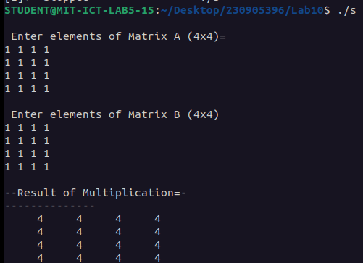
Output:

